**Fix Bugs of the application**

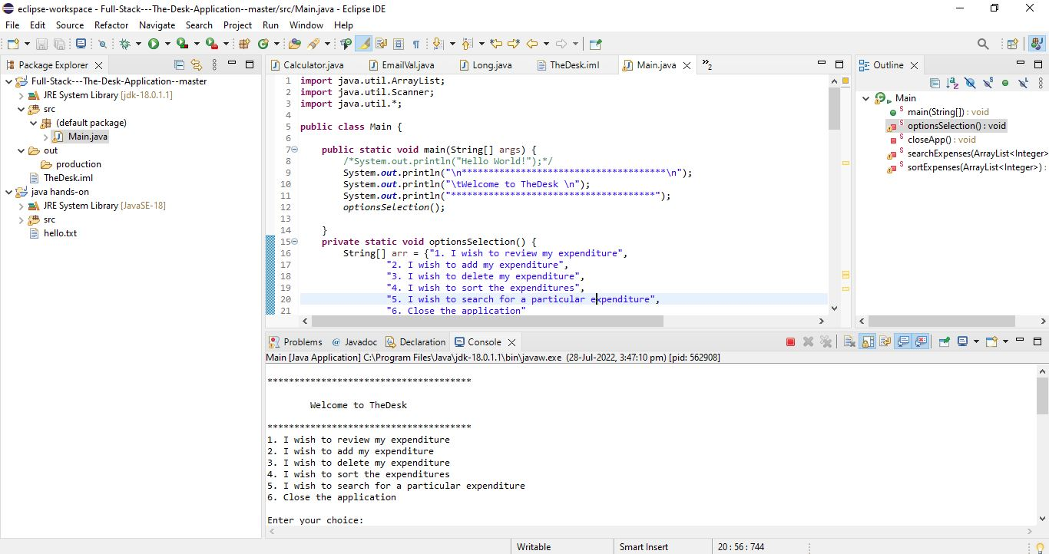

Options can be selected to do the operations

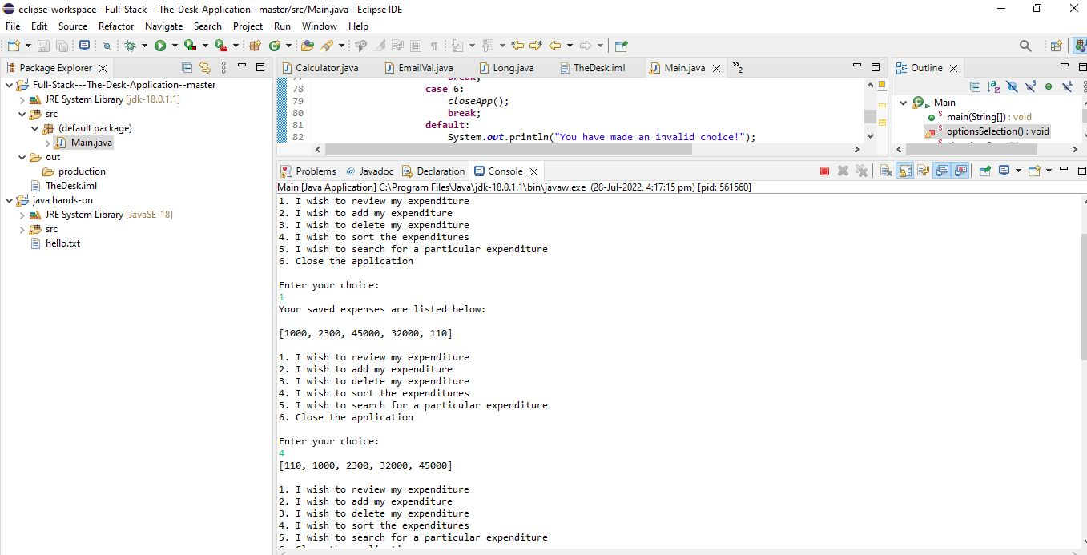

Selected 1 to view the list

Then selected 4 to sort

Then sorted list is available

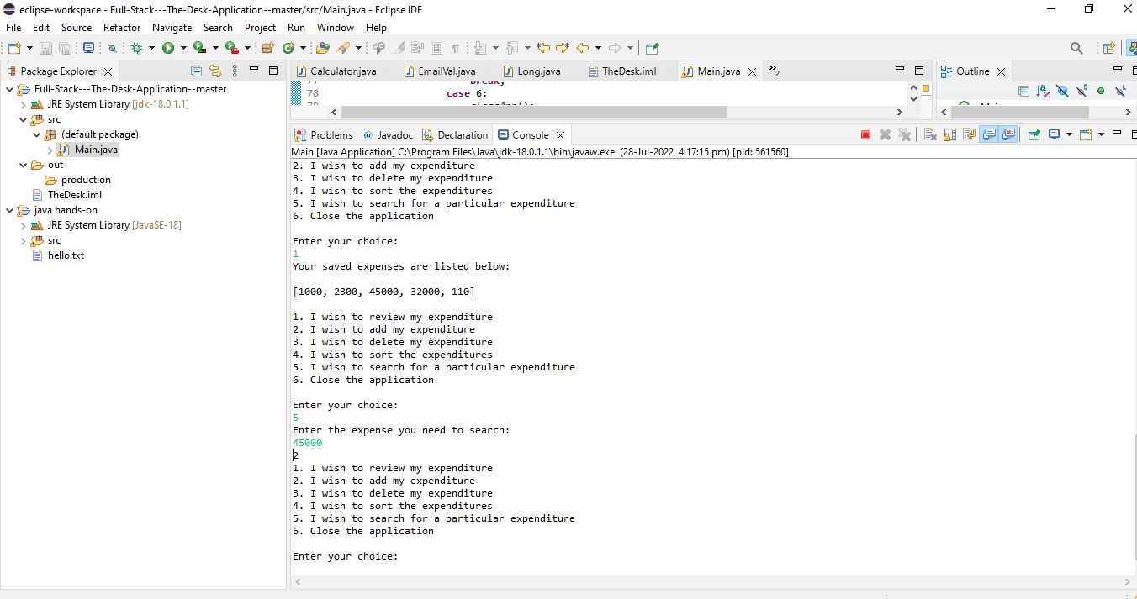

Selected 1 to view the array list

Then I selected option 5, which is for search, then entered the element to search, its index is returned